Customer Segmentation-Project Report

1. Project Overview
The Customer Segmentation Analysis project focuses on understanding customer purchasing behaviour using transactional data from the U.S. retail market. The dataset consists of 3,900 customer records containing demographic details, purchase information, payment methods, seasonal trends, and location data.
The analysis is performed using SQL for data extraction and Power BI for visualization to evaluate key business metrics such as Total Sales, Total Transactions, Average Order Value, and Customer Distribution. The project identifies sales patterns across product categories, age groups, payment methods, discounts, seasons, and locations.
The insights derived from this analysis support customer segmentation, discount optimization, and targeted marketing strategies, enabling businesses to make data-driven decisions and improve overall performance.
2. Dataset Summary
The dataset contains 3,900 customer transaction records from the U.S. retail market. It includes customer demographics, purchase details, product categories, payment methods, discounts, seasons, and location data. This dataset enables effective analysis of customer behaviour and segmentation for business decision-making.
3. Project Objectives
The project is designed to answer the following business questions using Power BI visualizations:
- What are the total sales, total transactions, average order value, and total customer count?
- How are total sales distributed across different product categories?
- How do discount and non-discount sales compare across product categories?
- What is the distribution of sales by different payment methods?
- How does average customer spending varies across different age groups?
- Which age groups contribute the highest sales and transaction volumes?
- How do sales trends vary across different seasons?
- How are sales geographically distributed across different locations?
- How do payment methods relate to customer spending behaviour?
- Which customer segments contribute the highest overall revenue

4. Dashboard in Power BI
Finally, we built an interactive dashboard in Power BI to present insights visually.
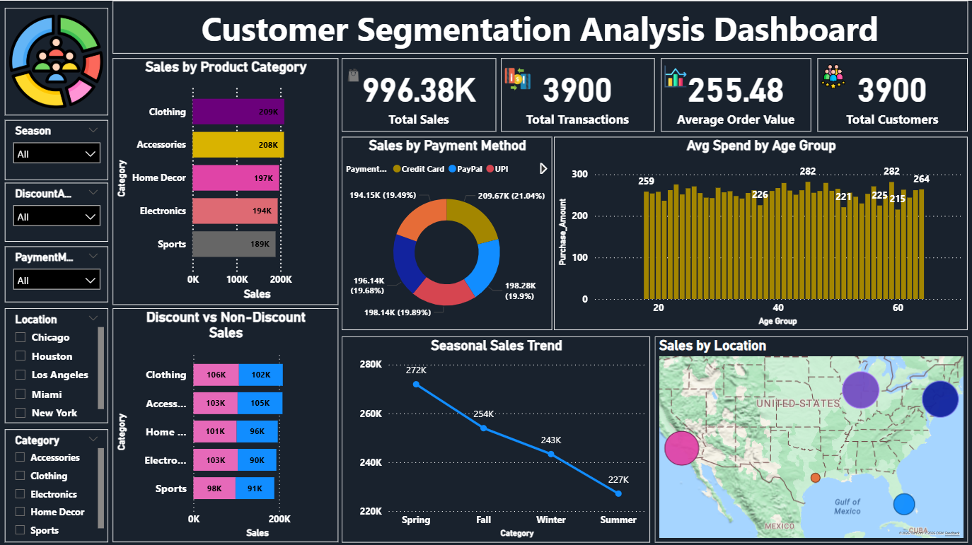

6. Business Summary
The analysis shows that total sales of approximately $996K were generated from 3,900 customer transactions, with an average order value of around $255. Sales are primarily driven by a few key product categories, which contribute the majority of overall revenue.
Middle-aged customers generate higher average spending compared to younger and older age groups, making them the most valuable customer segment. Payment analysis indicates that card-based payments are the most preferred method, while cash usage is comparatively lower.
Seasonal trends reveal higher sales during specific seasons, and geographic analysis shows that sales are concentrated in certain locations. Discounted sales contribute less revenue than non-discounted sales, indicating that discounts should be applied selectively rather than uniformly.
Overall, the project highlights clear customer segments and purchasing patterns that can be leveraged to optimize discount strategies, improve targeting, and enhance business performance.

7. Business Recommendations
1. Apply Discounts Strategically
Focus discounts on underperforming product categories rather than top-selling ones, as non-discounted sales generate higher overall revenue.
2. Target High-Value Age Groups
Prioritize customers in middle age groups, as they show higher average spending and contribute significantly to total sales.
3. Promote Card-Based Payments
Strengthen partnerships with banks and digital payment providers to offer card-based incentives, as cards are the most preferred payment method.
4. Leverage Seasonal Trends
Plan marketing campaigns and inventory around high-performing seasons to maximize sales opportunities.
5. Use Location-Based Targeting
Focus regional promotions on high-sales locations and develop targeted strategies to improve performance in lower-contributing regions.
6. Increase Average Order Value
Introduce product bundling, cross-selling, and personalized recommendations to encourage higher per-transaction spending.

